1. Step 05: <https://github.com/in28minutes/MockitoTutorialForBeginners/blob/master/Step05.md>
2. **Agenda**: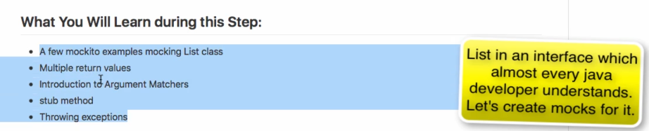
3. A little revision what we did till now when mocking an interface or class.  
   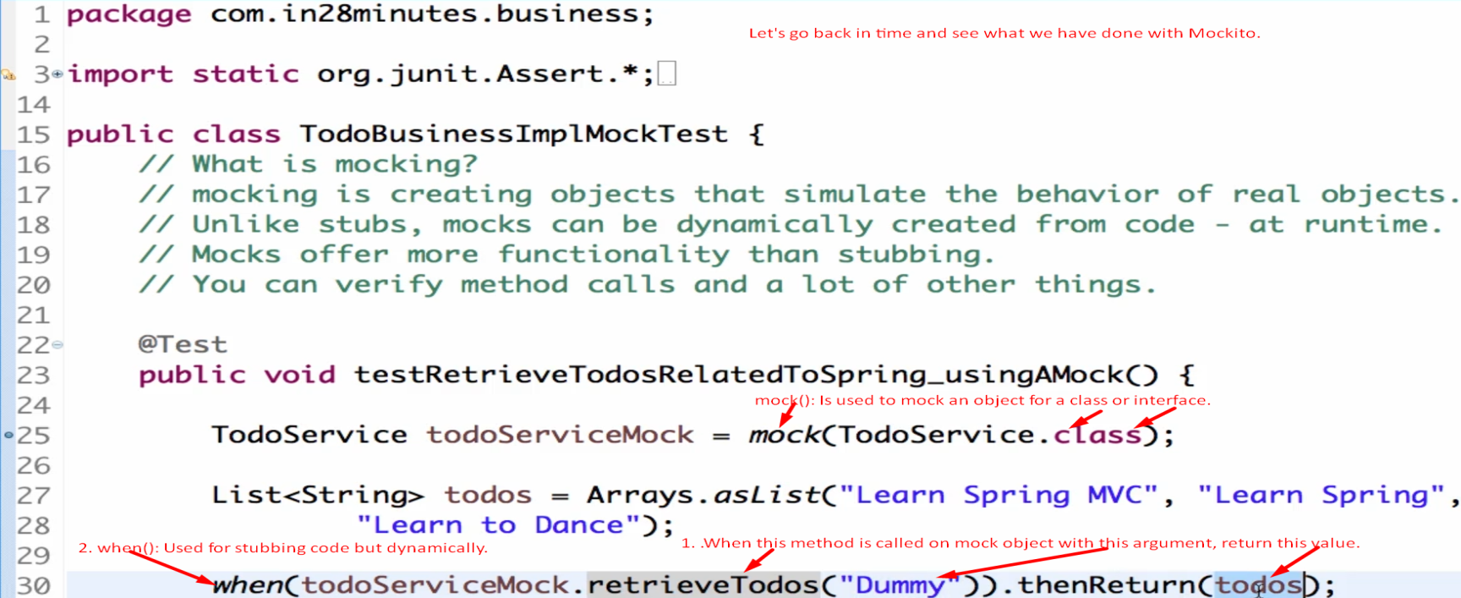  
   **mock**(<interface_or_class_.class>): To mock an interface or a class.  
   **when**(mockObj.methodName(<param_list>)).**thenReturn**(<return_value>): To stub method in the mock obj.
4. Let’s **mock** **java.util.List** interface.

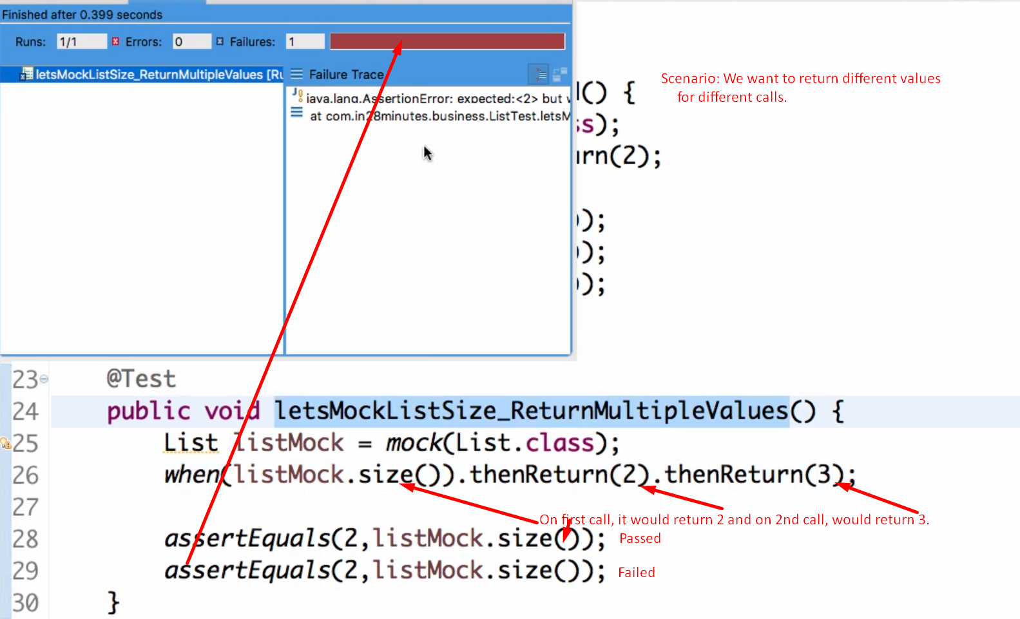

1. Mocking the **List.get(0)** method.  
   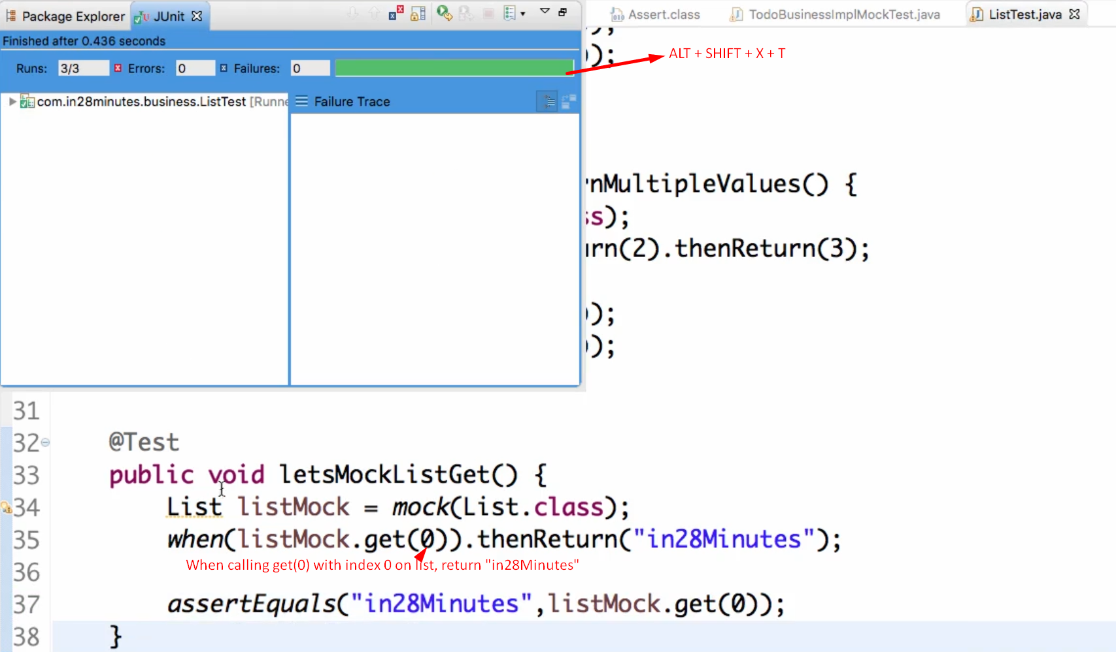
2. If we don’t stub a method like List.get(1), then the default value will be returned.  
   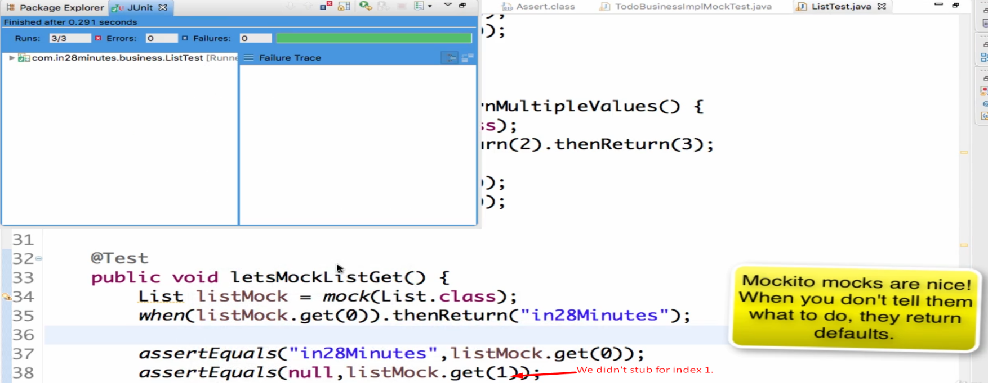

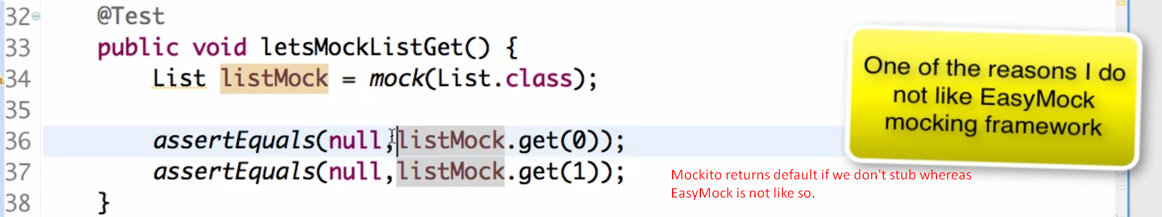

1. If we want to mock List.get(int) method for any int argument, we can pass Mockito.**anyInt()**This concept is **called Argument Matcher.**  
   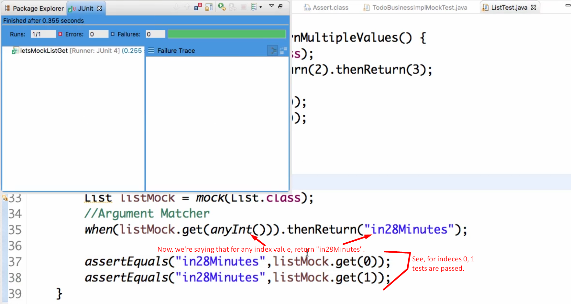

See **Mockito** **class** extends from **Matcher class**.  
See we have a bunch of **any matchers**.

1. 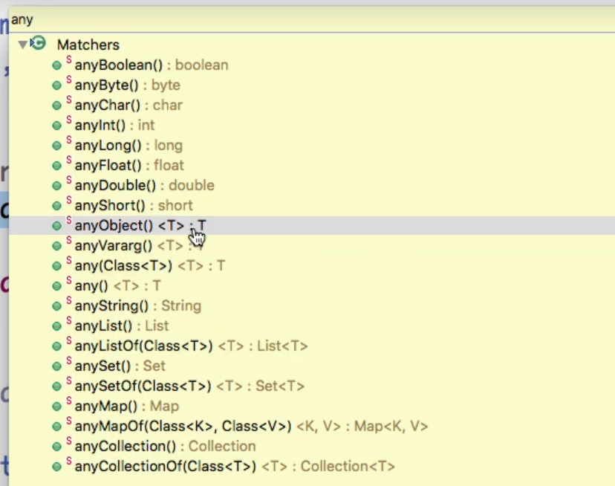
2. 